P1 Maths Revision Notes

Ordering and Sequence

Exercise 1: What is the next shape? Draw it in the .

1.
2.
3.
4.
1 2 3 4

Exercise 2: The following numbers are in ascending order. Fill in the missing numbers.
1
1.

5

2.

7
3.

4 3 2 1

Exercise 3: The following numbers are in descending order. Fill in the missing numbers.

1.
11

6
2.

Left Right

Exercise 4:

8 people are waiting to buy ice cream. Staring from the right, fill in the boxes from 1 to 8 on the boxes.

Numbers 1-5
Count and match with the correct numbers.

1.
2.
3.
4.
5.
6.
● ● ●
5
●
3
● ●
●
2
● ● ●
4
● ● ● ●
Addition
Exercise 1: Fill in the missing numbers.

1.  5 + 6 = ________________ | 2.  3 + 4 = ________________
3.  7+ 3 = ________________ | 4.  6 + 8 = ________________
5.  10 + 7 = ________________ | 6.  9 + 7 = ________________
7.  1 + 3 + 6 = ________________ | 8.  2 + 4 + 6 = ________________
9.  5 + 1 + 3 = ________________ | 10.  4 + 3 + 2 = ________________
11.  9 + 3 + 4 = ________________ | 12.  10 + 3 + 6 = ________________
Subtraction
Exercise 1: Fill in the missing numbers.

1.  9- 6 = ________________ | 2.  10 - 4 = ________________
3.  7- 3 = ________________ | 4.  8 - 6 = ________________
5.  10 - 7 = ________________ | 6.  19 - 7 = ________________
7.  10 – 1 – 3 = ______________ | 8.  12 – 2 – 6 = _______________
9.  15 – 4 – 3 = ______________ | 10.  8 – 1 – 2 = ______________
Addition and Subtraction
1. How many are there altogether?  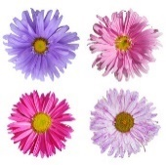  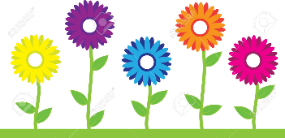  ( ) + ( ) = ( )  There are ( ) flowers altogether. | 2. Sam has 11 sweets. He ate 4 sweets yesterday.  How many sweets does he have now?  ( ) - ( ) = ( )  He has ( ) sweets now.
Ordering and sequence
Fill in the blanks.

1st 2nd 3rd 6th 8th 10th

1 | 1st | First | 6 | 6th | Sixth
2 | 2nd | Second | 7 | 7th | Seventh
3 | 3rd | Third | 8 | 8th | Eighth
4 | 4th | Fourth | 9 | 9th | Ninth
5 | 5th | Fifth | 10 | 10th | Tenth

Do the following.

1. Circle the 6th apple.
2. Cross out the 3rd star.

3. Circle the seventh apple.
4. Circle the second apple. Cross out the fifth apple from the right.
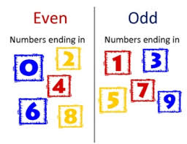
Odd and even numbers

Even numbers: 0, 2, 4, 6, 8, 10, 12

Odd numbers: 1, 3, 5, 7, 9, 11, 13, 15

Circle the even numbers.
1 5 23 45 22 68 456
43 56 78 233 65 44 34 20 90
55 63 25 50 51 52 74 88 85

Circle the odd numbers.
879 56 21 488 36 4 41 2 3 46 87 45 62 12 13 47 0 1
99 67 34 78 77 90 234 48 73

Fill in the missing numerals in the correct order.

3 |  | 7 |  |  |  | 15
1.

 | 4 | 6 |  | 10
2.

19 |  | 15 |  |  |  | 7
3.

 |  |  | 12 |  |  | 6
4.

Color the square having odd number with red.
Color the square having even numbers with blue.

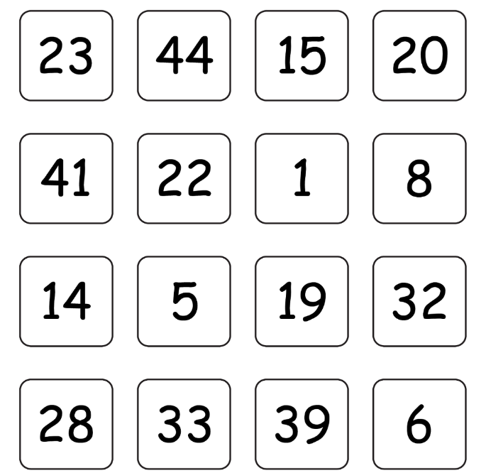

Count and say whether the number is ‘odd’ or ‘even’.

e.g. | 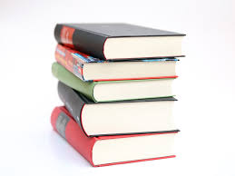 | There are ___five___ books.  It is an __odd__ number.
1. | 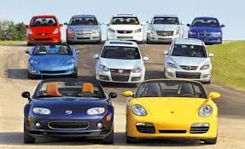 | There are __________ cars.  It is an ____________ number.
2. |  | There are _________ pencils.  It is an _____________ number.
Blocks, Cylinders, Pyramids and Balls
Exercise 1: Do the matching.
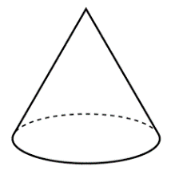
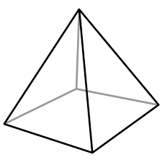

● ● ● ● ●

● ● ● ● ●
Block pyramid cone cylinder ball

Exercise 2: Study the pictures and answer the questions.
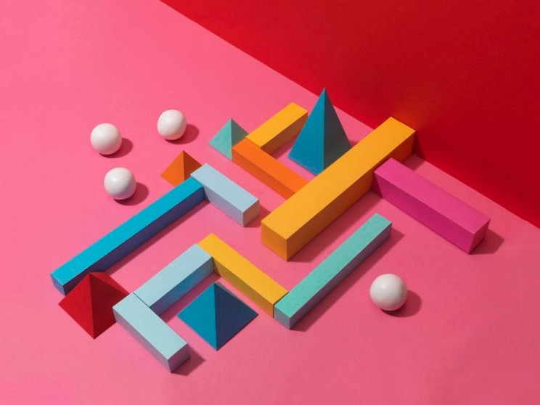

1. There are ______________ balls in the picture.
2. There is ________________ cone.
3. There are __________________ cylinders.
4. There are ___________________ rectangular blocks.
5. There are ____________________________ pyramids.

