Primary 4 General Study Quiz 2

1) Most ancient civilisations began near __________ such as in China and Egypt.

2) Water is used in _____________ production, ____________ production and driving different _____________ .

3) State 4 uses of water.
(a) _____________
(b) _____________
(c) _____________
(d) _____________

4) Moving water provides ____________ power. In a hydropower plant, ____________ water pushes the turbine, driving the generator to produce ____________.

5) States 3 properties of water.
(a) _____________
(b) _____________
(c) _____________

6) What are the different states of water?
_____________________________________________________________
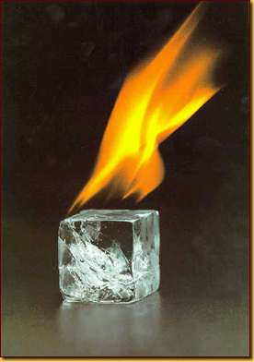
7) When heated, ice ___________ and turns into water.

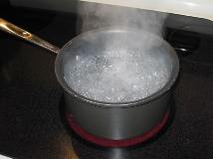
8) When heated, water ___________ and turns into __________________ .
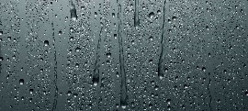
9) When cooled, water vapour _____________ into water.
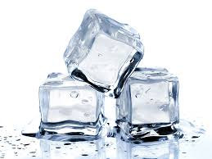
10) When cooled, water freezes and turns into
___________ .
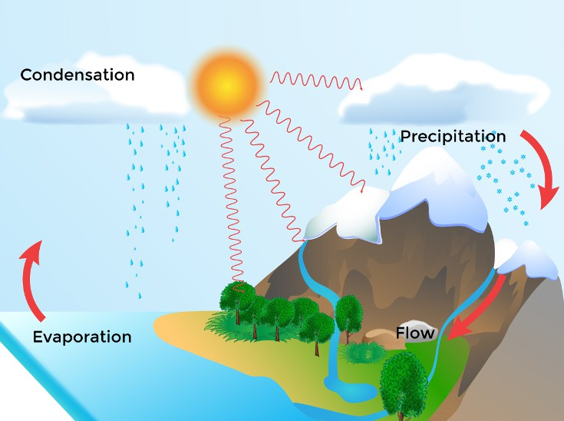
11)

(a) As water droplets increase in size, they fall onto the ground as __________.

(b) When water is heated by the Sun, it evaporates and turns into ________________.

(c) __________________ comes into contact with cool air and condenses into tiny water droplets. The water droplets gather in the sky and form _________.

The above process is called the ____________________ .
12) Water from ______________ has been imported from the Mainland to meet the needs of the people in Hong Kong.

13) The Hong Kong government has built a number of ___________ to collect rainwater.

14) ___________ is added to tap water to protect our teeth.

15) Water from reservoirs undergoes the processes of ________________ and ______________ in water treatment works. ____________ and ____________ are added to the water.

16) States 4 properties of air.
(a) _____________
(b) _____________
(c) _____________
(d) _____________

17) When heated, air ____________ and the ____________ air nearby moves in to fill the space. The movement of air results in __________.
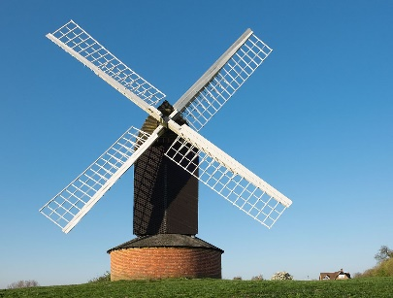
18) How does a windmill works? Write 1 to 3.
( ) The spinning of blades drives the generator.
( ) Wind makes the blade of the wind turbine spin.
( ) The generator produces electricity.
19) What is the following gases in air?
(a) Gas A makes up 78% of air: ________________
(b) Gas B makes up 1% of air: ______carbon dioxide ____
(c) Gas C makes up 21% of air: _________________
(d) We need Gas _( A / B / C )__ to survive.
(e) I breathe in Gas ______ and breathe out Gas ______ and water vapour.

20) ___________ is needed to burning. When it is used up, the fire ____________________ .

21) __________________ is given off in burning.

22) Why do people fan the barbeque fire?
It is because fanning makes the air flow. It increases the supply of ___________ needed in burning.

23) Why is sand used to put out fire?
It is because sand can separate fire from _____________ . It is often used to put out fire by _______________ the oxygen supply.

24) Why does people paint the iron gates?
It is because coating the gate with paint will separate the __________ and _________ . It helps prevent the gate from _____________.

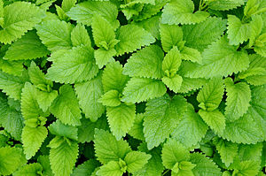
25) Most plants can produce their own food. The _____________ in the leaves uses sunlight as energy and produces food using __________ and ___________________. Sugar is produced and is stored in the form of _________ for plant growth.
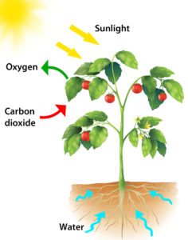
26) Plants produce food by the process called ________________. During this process, plants take in __________________ and give off _________________ .

Answer
1) river
2) industrial , power , machines.
3) Farming , Water transport, fish farming, industrial production, fire fighting, driving machines, power production (any 4)
4) driving , moving , electricity
5) no colour , no taste , no smell
6) Gas, liquid, solid
7) melts
8) evaporates, water vapour
9) condenses
10) ice
11) (a) rain (b) water vapour (c) Water vapour, cloud (d) Water cycle
12) Dong Jiang
13) reservoirs
14) Flouride
15) Sedimentation, filtration, Chlorine, fluoride
16) No colour, no smell, no taste, no shape
17) rises, nearby, wind
18) 2, 1, 3
19) (a) Nitrogen , (c) Oxygen, (d) C , (e) C, B
20) Oxygen, goes out
21) Carbon dioxide 22) oxygen 23) oxygen, cutting off 24) air, water, rusting
25) chlorophyll, water, carbon dioxide, starch
26) photosynthesis, oxygen, carbon dioxide

