P4
English revision exercise

(first term exam revision)

Name: _________________________

Part A. Fill in with the correct form of the adjective in brackets.

1. The Nile is (long) _________________________ river in the world.

2. Butterflies are (beautiful) _____________________________ animals you can find.

3. My desk is (tidy) __________________________ David's.

4. A lot of people drink (hot) _____________________ milk.

5. Latin is (boring) ________________________________ than Spanish.

6. She always has a (cold) __________________ shower in the morning.

7. Who's (intelligent) ________________________ student in your class?

8. Who's (good) _____________________ tennis player in your country?

9. The blue whale is (heavy) ___________________ animal in the world.

10. Travelling by car is (comfortable) ____________________________
travelling by bus.

Part B. Complete the sentences.

1. Panda Café, Sky Café and Baby Café are all good.
Sky Café is better than Baby Café.
Panda Café is the best café.
__________________________Cafe
__________________________Cafe
_________________________Cafe

A Hotel
B Hotel
C Hotel
2.

A Hotel, B hotel and C hotel are all ________________________. B hotel is ___________________________________________________________. C hotel is ____________________________________________.

King Restaurant
Silver Restaurant
Moonlight Restaurant
3.

________________________________________________________________________________

________________________________________________________________________________

Part C. Andy and Jenny are looking at the menu. Finish what they say.

Menu | Andy | Jenny | Menu | Andy | Jenny
1. Salad |  |  | 3. Soup noodles
Tuna salad |  |  | Soup noodles with dumplings
Prawn salad |  |  | Soup noodles with pork chop
2. Curry |  |  | 4. Pudding
Chicken curry |  |  | Mango pudding
Beef Curry |  |  | Chocolate pudding

1. Mum: Which would you like, tuna salad ________ prawn salad?

Andy: I’d like ____________________________________________________.

Jenny: I’d like ____________________________________________________.

2. Mum: What would you like?

Andy and Jenny: We’d like _________________________________________.

3. Mum: Which would you like, ___________________________________?

Andy: I’d like ____________________________________________________.

Jenny: I’d like ____________________________________________________.

4. Mum: Which would you like, ___________________________________?

Andy and Jenny: We’d like _________________________________________.
Part D. Candy is writing about an interview of her grandma. Help her finish it.

When Grandma was young, did anybody in her class…
1. have a DVD player? |  | 4. play hide-and-seek?
2. have a radio? |  | 5. play Chinese chess?
3. have an MP3 player? |  | 6. play electronic games?

1. Everybody had a DVD player.

2. Nobody had a radio.

3. ______________________________________________________________.

4. ______________________________________________________________.

5. ______________________________________________________________.

6. ______________________________________________________________.
Part E. Ask and answer questions about A City today and 20 years ago.
A City 20 years ago | 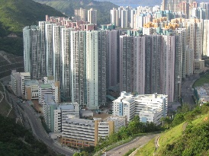  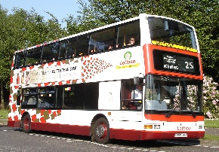
A City today | 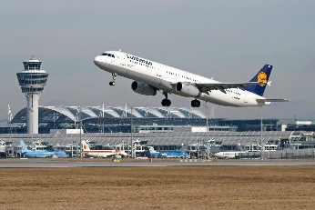  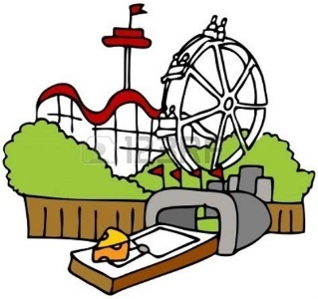  4  3  2  1
1. Q: There are buses in A City now. ________________ there

_________________ buses 20 years ago?

A: Yes, ____________________________________________.

2. Q: ______________________________________________. _____________________

______________________________________________________________________?

A: ____________________________________________________.
3. Q: ______________________________________________. _____________________

______________________________________________________________________?

A: ____________________________________________________.

4. Q: ______________________________________________. _____________________

______________________________________________________________________?
A: ____________________________________________________.
Part F. Look at the table and finish what the children say.

 |  | 3 years old | Now
Jenny | 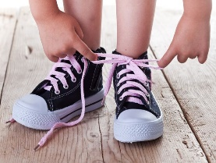
Andy | 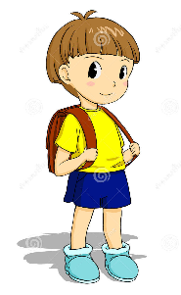

1. Mum: You couldn’t tie your shoelaces by yourself.

Jenny: I can _________________________________ by ___________________ now.

2. Mum: You couldn’t _____________________________________________________.

Jenny: I can _________________________________ by ___________________ now.

3. Mum: ___________________________________________________________________.

Andy: ____________________________________________________________________.

Part G. Finish the sentences.

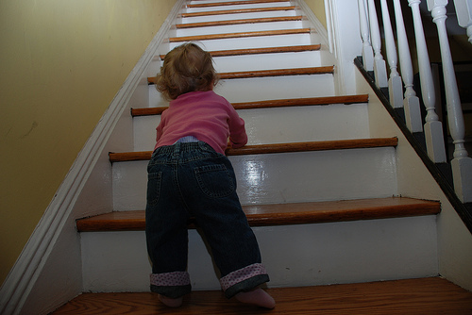  1.  未知的作者 的 此相片 已透過 CC BY-SA 授權  This is Amy. She could _____________  __________________________ by herself  when she was three. | 2.  Helen could ______________________  _________________by_________________  when ______________________________.
3.  Gigi and Bob ________________________  _______________________________________  ________________________________________. | 4.  Jim ___________________________________  _______________________________________  ________________________________________.

Part H. There are some mistakes in the below paragraph. Circle the correct answer.

This morning, I 1.) were making toast for 2.) brakfast. Then I went to the basement 3.) put some clothes in the washer. I heard the smoke alarm. I 4.) think, “Someone is burning 5.) something I put the soap in the washer. When I got 6.) up to stairs, everybody was running outdoors. Two fire trucks and a police car were outside of my home. Smoke was coming out of my apartment! My kids 7.) standing outside. They were 8.) weering their pajamas. My kids! Oh no! my toast!

1.)  A. are  B. is  C. was  D. Correct  2.  A. brakfast  B. breckfast  C. breakfast  D. breackfast  3.)  A. to put  B. for put  C. to puts  D. for putting  4.)  A. Thinked  B. I thinked  C. I thought  D. I am thought | 5.)  A. something!  B. something!”  C. something”!  D. something”?  6.)  A. upstairs  B. to upstairs  C. the upstairs  D. Correct as is  7.)  A. was standing  B. are standing  C. were stand  D. were standing  8.)  A. waring  B. wareing  C. wearing  D. Correct

