Primary 1 General Studies Revision

- Know myself
Eyes
Head
Ears
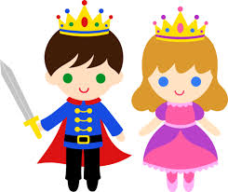
Hair
Mouth
Nose
Arm
Face
Foot
Leg
Hand

Exercise: Circle the correct answer
1) Does the prince have green eyes? Yes / No
2) Does the princess have brown eyes? Yes / No, she has blue eyes
3) Does the princess have curly hair? Yes / No
4) Does the prince have long ears? Yes / No
5) Does the prince have big eyes? Yes / No

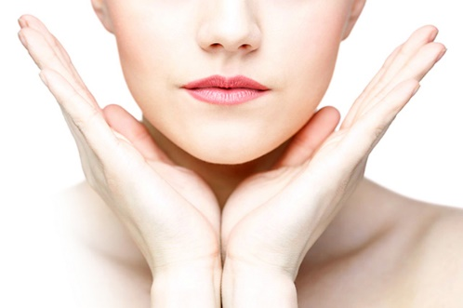
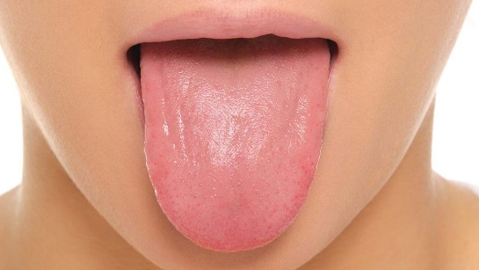
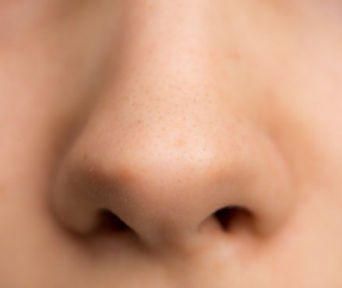
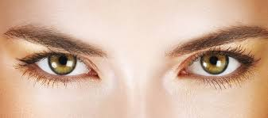
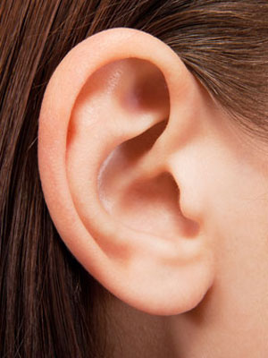
Touch
Taste
Smell
See
Hear
Skin
Tongue
Nose
Ears
Eyes

When I am growing, my milk teeth fall out and permanent teeth will grow soon.

We are all different. We should protect ourselves and respect others.

- Things I can do

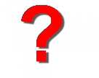
What is a good posture?
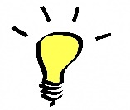
Good posture keeps our backbone in good shape.

What is good eating habit?
- We should have three regular and balanced meals every day.
- We should eat healthy food
- We should not waste food.
- We should have good table manners.
3 low | 1 high
Low in fat | High in fibre
Low in salt
Low in sugar

My timetable
We should spend time wisely and set a timetable.
- School
What should be do when going to school?

What facilities do school have?

There are many facilities in school. We should take care of them.
- School Life

Different people have different duties in a school, we should be helpful to each other.

What subjects do we study in school?

What is your favourite subject?

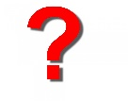
What activities do your school have? Circle them

Which activities have you joined?

Why join school activities? Learn new skills

School Rules

- Our school set up rules to keep the school in order.
- We should follow the school rules.
- Teachers, prefects and class monitors help keep the school in order. We should listen to them.

